Tag, push, and pull your image

In this section, you tag and push your docker-whale image to your newly created repository. When you are done, you test the repository by pulling your new image.

Step 1: Tag and push the image

If you don’t already have a terminal open, open one now:

1. Go back to your command line terminal.
2. At the prompt, type docker images to list the images you currently have:
3. $ docker images
4. REPOSITORY TAG IMAGE ID CREATED SIZE
5. docker-whale latest 7d9495d03763 38 minutes ago 273.7 MB
6. <none> <none> 5dac217f722c 45 minutes ago 273.7 MB
7. docker/whalesay latest fb434121fc77 4 hours ago 247 MB
8. hello-world latest 91c95931e552 5 weeks ago 910 B
9. Find the IMAGE ID for your docker-whale image.

In this example, the id is 7d9495d03763.

Notice that currently, the `REPOSITORY` shows the repo name `docker-whale`

but not the namespace. You need to include the `namespace` **for** Docker Hub to

associate it **with** your account. The `namespace` is the same **as** your Docker

Hub account name. You need to rename the image to

`YOUR_DOCKERHUB_NAME/docker-whale`.

1. Use IMAGE ID and the docker tag command to tag your docker-whaleimage.

The command you type looks like this:

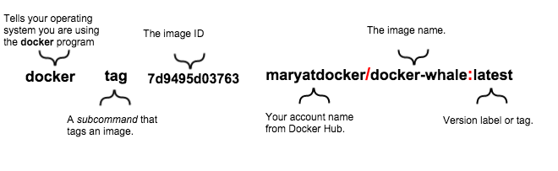

Of course, your account name will be your own. So, you type the command with your image’s ID and your account name and press RETURN.

$ docker tag 7d9495d03763 maryatdocker/docker-whale:latest

1. Type the docker images command again to see your newly tagged image.
2. $ docker images
3. REPOSITORY TAG IMAGE ID CREATED SIZE
4. maryatdocker/docker-whale latest 7d9495d03763 5 minutes ago 273.7 MB
5. docker-whale latest 7d9495d03763 2 hours ago 273.7 MB
6. <none> <none> 5dac217f722c 5 hours ago 273.7 MB
7. docker/whalesay latest fb434121fc77 5 hours ago 247 MB
8. hello-world latest 91c95931e552 5 weeks ago 910 B
9. Use the docker login command to log into the Docker Hub from the command line.

The format for the login command is:

docker login

When prompted, enter your password and press enter. So, for example:

$ docker login

Login with your Docker ID to push **and** pull images from Docker Hub. **If** you don't have a Docker ID, head over to https://hub.docker.com to create one.

Username:

Password:

Login Succeeded

1. Type the docker push command to push your image to your new repository.
2. $ docker push maryatdocker/docker-whale
3. The push refers to a repository [maryatdocker/docker-whale] (len: 1)
4. 7d9495d03763: Image already exists
5. c81071adeeb5: Image successfully pushed
6. eb06e47a01d2: Image successfully pushed
7. fb434121fc77: Image successfully pushed
8. 5d5bd9951e26: Image successfully pushed
9. 99da72cfe067: Image successfully pushed
10. 1722f41ddcb5: Image successfully pushed
11. 5b74edbcaa5b: Image successfully pushed
12. 676c4a1897e6: Image successfully pushed
13. 07f8e8c5e660: Image successfully pushed
14. 37bea4ee0c81: Image successfully pushed
15. a82efea989f9: Image successfully pushed
16. e9e06b06e14c: Image successfully pushed
17. Digest: sha256:ad89e88beb7dc73bf55d456e2c600e0a39dd6c9500d7cd8d1025626c4b985011
18. Return to your profile on Docker Hub to see your new image.

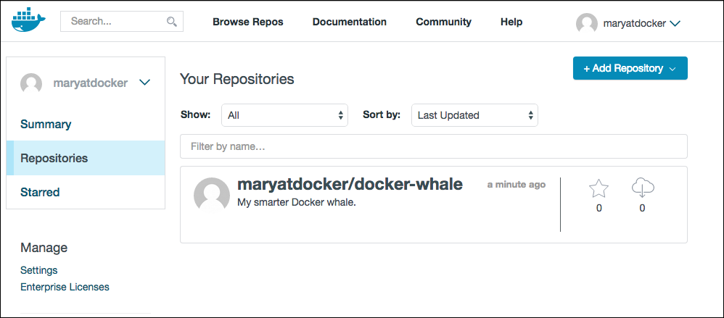

Step 2: Pull your new image

In this last section, you’ll pull the image you just pushed to hub. Before you do that though, you’ll need to remove the original image from your local machine. If you left the original image on your machine, Docker would not pull from the hub — why would it? The two images are identical.

1. Make sure Docker is running, and open a command line terminal.
2. At the prompt, type docker images to list the images you currently have on your local machine.
3. $ docker images
4. REPOSITORY TAG IMAGE ID CREATED SIZE
5. maryatdocker/docker-whale latest 7d9495d03763 5 minutes ago 273.7 MB
6. docker-whale latest 7d9495d03763 2 hours ago 273.7 MB
7. <none> <none> 5dac217f722c 5 hours ago 273.7 MB
8. docker/whalesay latest fb434121fc77 5 hours ago 247 MB
9. hello-world latest 91c95931e552 5 weeks ago 910 B

To make a good test, you need to remove the maryatdocker/docker-whaleand docker-whale images from your local system. Removing them forces the next docker pull to get the image from your repository.

1. Use the docker rmi to remove the maryatdocker/docker-whale and docker-whale images.

You can use an ID or the name to remove an image.

$ docker rmi -f 7d9495d03763

$ docker rmi -f docker-whale

1. Pull and load a new image from your repository using the docker runcommand.

The command you type should include your username from Docker Hub.

docker **run** yourusername/docker-whale

Since the image is no longer available on your local system, Docker downloads it.

$ docker run maryatdocker/docker-whale

Unable to find image 'maryatdocker/docker-whale:latest' locally

latest: Pulling from maryatdocker/docker-whale

eb06e47a01d2: Pull complete

c81071adeeb5: Pull complete

7d9495d03763: Already **exists**

e9e06b06e14c: Already **exists**

a82efea989f9: Already **exists**

37bea4ee0c81: Already **exists**

07f8e8c5e660: Already **exists**

676c4a1897e6: Already **exists**

5b74edbcaa5b: Already **exists**

1722f41ddcb5: Already **exists**

99da72cfe067: Already **exists**

5d5bd9951e26: Already **exists**

fb434121fc77: Already **exists**

Digest: sha256:ad89e88beb7dc73bf55d456e2c600e0a39dd6c9500d7cd8d1025626c4b985011

Status: Downloaded newer image **for** maryatdocker/docker-whale:latest

________________________________________

/ Having wandered helplessly into a \

| blinding snowstorm Sam was greatly |

| relieved to see a sturdy Saint Bernard |

| dog bounding toward him with the |

| traditional keg of brandy strapped to |

| his collar. |

| |

| "At last," cried Sam, "man's best |

\ friend -- and a great big dog, too!" /

----------------------------------------

\

\

\

*## .*

*## ## ## ==*

*## ## ## ## ===*

/""""""""""""""""___/ ===

~~~ {~~ ~~~~ ~~~ ~~~~ ~~ ~ / ===- ~~~

\______ o __/

\ \ __/

\____\______/

Where to go next

You’ve done a lot, you’ve done all of the following fundamental Docker tasks.

* installed Docker
* run a software image in a container
* located an interesting image on Docker Hub
* run the image on your own machine
* modified an image to create your own and run it
* create a Docker Hub account and repository
* pushed your image to Docker Hub for others to share